Statistical analysis
2026-10-03

Valence
Friedman rank sum test on MAE across models: χ²(4) = 106.13, p < .001.
Table . Outcomes of Wilcoxon signed-ranks pairwise post hoc tests for models predicting valence responses.
Comparison | Estimated Median Difference in MAE | p_adjusted | Effect size
C-DCNN x DCNN | -0.008 | p < 0.001 | 0.240
C-DCNN x DFNN | -0.061 | p < 0.0001 | 0.980
C-DCNN x LR | -0.075 | p < 0.0001 | 0.990
C-DCNN x RF | -0.089 | p < 0.0001 | 1.000
DCNN x DFNN | -0.052 | p < 0.0001 | 0.940
DCNN x LR | -0.066 | p < 0.0001 | 0.970
DCNN x RF | -0.080 | p < 0.0001 | 1.000
DFNN x LR | -0.014 | 0.093 | 0.320
DFNN x RF | -0.029 | p < 0.0001 | 0.720
LR x RF | -0.017 | 0.076 | 0.380

Tense arousal
Friedman rank sum test on MAE across models: χ²(4) = 100.19, p < .001.
Table . Outcomes of Wilcoxon signed-ranks pairwise post hoc tests for models predicting tense arousal responses.
Comparison | Estimated Median Difference in MAE | p_adjusted | Effect size
C-DCNN x DCNN | -0.007 | p < 0.005 | 0.270
C-DCNN x DFNN | -0.055 | p < 0.0001 | 0.960
C-DCNN x LR | -0.073 | p < 0.0001 | 1.000
C-DCNN x RF | -0.072 | p < 0.0001 | 1.000
DCNN x DFNN | -0.050 | p < 0.0001 | 0.940
DCNN x LR | -0.067 | p < 0.0001 | 0.990
DCNN x RF | -0.066 | p < 0.0001 | 1.000
DFNN x LR | -0.017 | 0.013 | 0.480
DFNN x RF | -0.017 | p < 0.0001 | 0.440
LR x RF | -0.001 | 1 | 0.010

Energetic arousal
Friedman rank sum test on MAE across models: χ²(4) = 71.47, p < .001.
Table . Outcomes of Wilcoxon signed-ranks pairwise post hoc tests for models predicting energetic arousal responses.
Comparison | Estimated Median Difference in MAE | p_adjusted | Effect size
C-DCNN x DCNN | -0.008 | p < 0.0001 | 0.310
C-DCNN x DFNN | -0.019 | p < 0.0001 | 0.690
C-DCNN x LR | -0.027 | p < 0.0001 | 0.840
C-DCNN x RF | -0.027 | p < 0.0001 | 0.870
DCNN x DFNN | -0.010 | p < 0.001 | 0.480
DCNN x LR | -0.019 | p < 0.001 | 0.650
DCNN x RF | -0.020 | p < 0.0001 | 0.700
DFNN x LR | -0.008 | 0.234 | 0.310
DFNN x RF | -0.008 | 0.008 | 0.380
LR x RF | -0.001 | 1 | 0.030

Model error distributions (paper Figure 3)
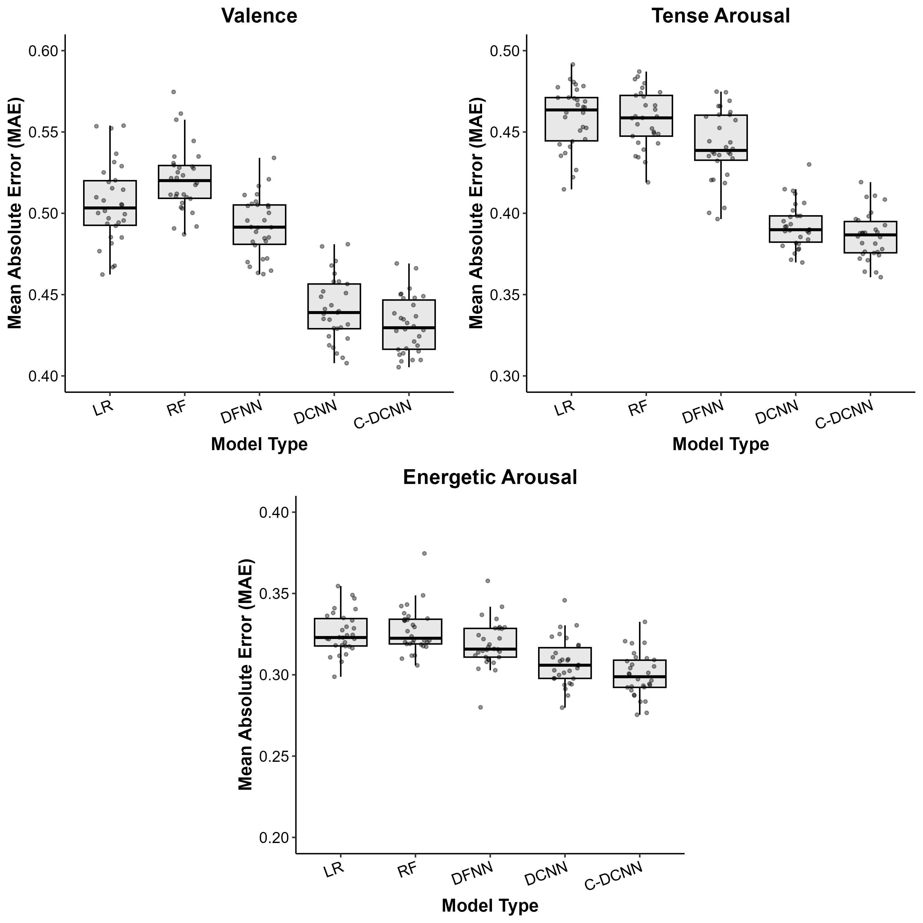
Figure . Mean absolute error (MAE) of each model for valence, tense arousal and energetic arousal.

Model performance summary (paper Table 3)
Table . Mean R², RMSE and MAE of each model for each response.
Response | Linear Model |  |  | Random Forest |  |  | DFNN |  |  | DCNN |  |  | C-DCNN
Response | R² | RMSE | MAE | R² | RMSE | MAE | R² | RMSE | MAE | R² | RMSE | MAE | R² | RMSE | MAE
Valence | 0.47 | 0.64 | 0.51 | 0.44 | 0.65 | 0.52 | 0.49 | 0.62 | 0.49 | 0.59 | 0.56 | 0.44 | 0.61 | 0.55 | 0.43
Tense Arousal | 0.61 | 0.58 | 0.46 | 0.60 | 0.59 | 0.46 | 0.61 | 0.57 | 0.44 | 0.69 | 0.51 | 0.39 | 0.70 | 0.50 | 0.39
Energetic Arousal | 0.79 | 0.42 | 0.33 | 0.79 | 0.42 | 0.33 | 0.80 | 0.41 | 0.32 | 0.81 | 0.40 | 0.31 | 0.82 | 0.39 | 0.30

